Registration procedure
The completed registration forms with declaration to deliver a conference contribution are to be sent at the following address:
The Szewalski Institute of Fluid-Flow Machinery
of the Polish Academy of Sciences
TEW Hydropower Consulting Bureau
ul. Fiszera 14, 80-231 Gdansk, Poland
phone: +48 58 52 25 139, e-mail: steller@imp.gda.pl; biuro@tew.pl
All other applications are to be sent to:
Biuro Towarzystwa Elektrowni Wodnych
ul. Piaskowa 18, 84-240 Reda, Poland
phone: +48 58 678 79 51, e-mail: biuro@tew.pl
Cancellations
Cancelling participation in the Conference is free of charge till August 20th. For cancellations after this date, but before September 15th, the delegate may be charged with costs up to 50 % of the basic Conference fee. In case of further cancellations the Organisers preserve their right to charge the delegate with full participation costs.
Meals and informal meetings
The Conference fee includes coffee breaks, two lunches and the Conference Dinner planned for the end of the first day of the debate. If you have planned your stay till October 11th, we’ll be delighted to welcome you to the reception of the TEW National Assembly at the same place on October 10th evening. Please declare as follows:
❑ I intend to take part in the Conference Dinner on 9.10.2019
❑ I intend to invite an accompanying person to the Dinner
❑ I intend to take part in the TEW Reception on 10.10.2019
❑ I intend to invite an accompanying person to the Reception
The Conference Dinner costs have been already included in the Conference fee. The additional charges for the Dinner and TEW Reception are 30 € or 120 PLN. In case of selecting a paid option the relevant charge will be added to your Conference invoice. The charge for TEW Reception does not apply to the TEW National Assembly delegates.
Conference venue and overnights
The Conference will take place in the South Eastern part of Poland, in the neighbourhood of Solina Dam (some 2 h car travel south of the city of Rzeszów). The final venue will be decided in the end of May. So far the organisers have booked hotel rooms on preference conditions both in Solina and Polanczyk (11 km distance by car). Further information on the subject will be sent to you in the beginning of June.

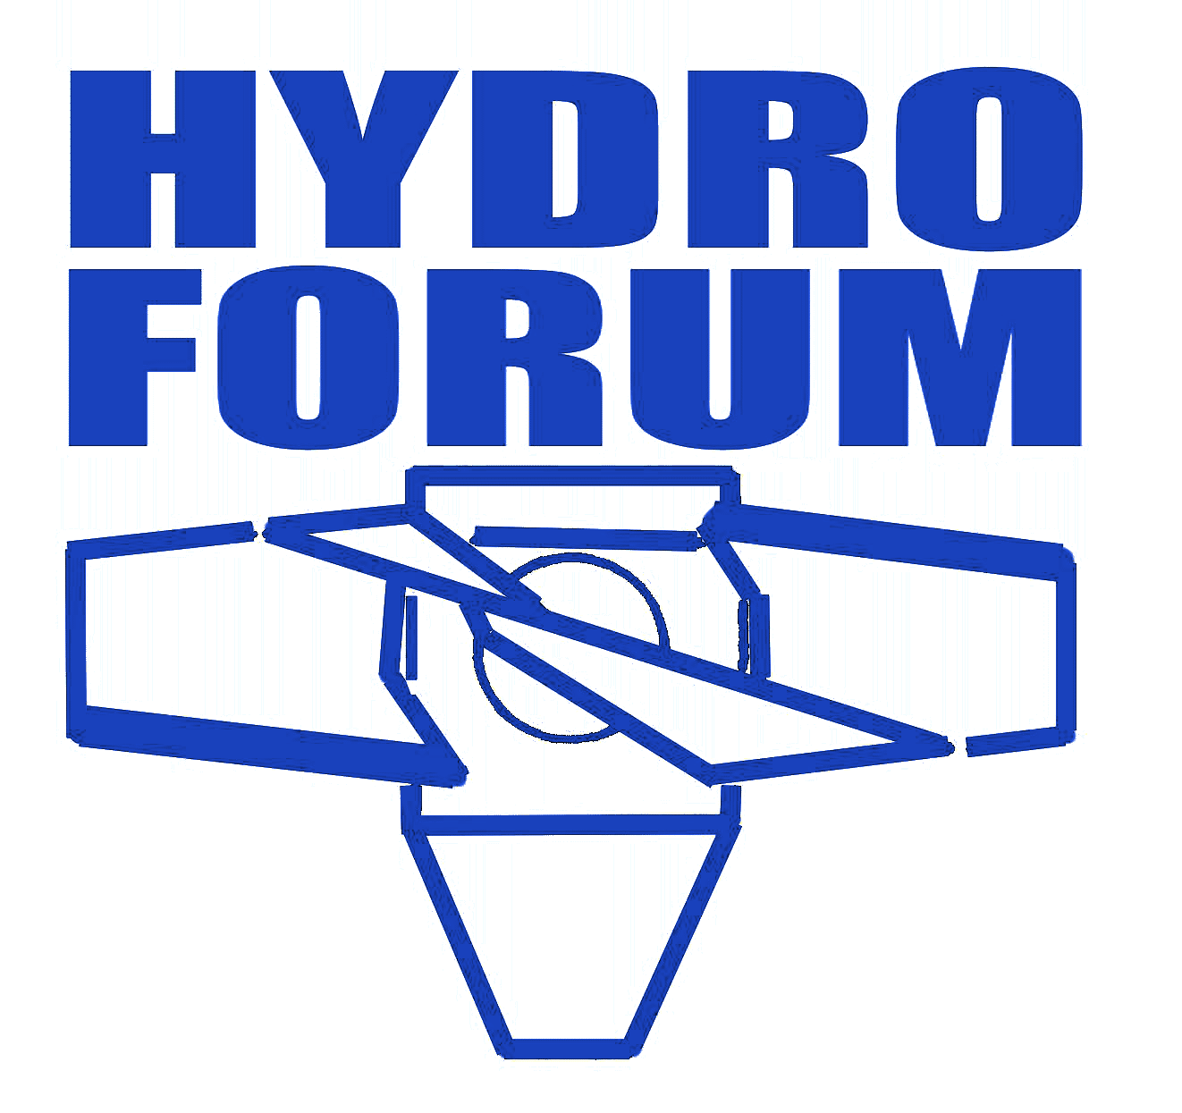
Polish Hydropower Conference
HYDROFORUM 2019
Solina, Poland, October 9-10th, 2019

CONFERENCE DELEGATE REGISTRATION FORM
Surname
and forenames ...............................................................................................
Professional or scientific title .........................................................................
Company/Institution ...........................................................................................
......................................................................................................................
Position ....................................................................................................
Correspondence address .................................................................................
......................................................................................................................
E-mail: ............................................. Phone. ...................................................
❑ I intend to join the Conference. Please, issue an invoice.
❑ I’m interested in the Conference. Please add me to your mailing list.
- I’m a national hydropower association member
- I'm a student
- I have been invited to chair a conference session, to join
the discussion panel or I intend to deliver a conference contribution,
- I'm a Conference guest or have been offered a special discount.

Place and date ......................................... Signature .........................................
Invoice payer data
Payer's name and address
......................................................................................................................
......................................................................................................................
......................................................................................................................
VAT …………………………………………………………………………………….
Conference charges
In case of declaring your participation in the Conference, this document will be the basis for issuing the invoice for persons not exempted from payment by the Conference Committee decision. The invoices will be issued after September 15th. The Conference fees follow from the table below.
Conference application date | till 15.09 | after 15.09
Basic fee | 230 € / 1000 PLN | 260 € / 1100 PLN
TEW/TRMEW members | 200 € / 850 PLN | 230 € / 1000 PLN
Authors, session chairmen, students | 145 € / 600 PLN | 170 € / 750 PLN
TEW reception / additional Conf. dinner | 30 € / 120 PLN | 30 € / 120 PLN
The aforementioned charges include the value added tax (VAT) at the 23 % rate. The accompanying persons will be charged solely with the conference dinner and the TEW reception costs (if relevant).
Arrival to the conference venue
The Conference Organisers expect major part of participants to arrive to the conference venue using their own transport means. The delegates planning to reach Rzeszów or Sanok by means of the public transport (eg. railway or airline) and to continue their travel using the transport opportunities offered by the Conference Organisers are invited to provide us a non-binding information on the subject by filling the table below. You'll be asked for a detailed information by September 16th.
 | Location | Airport/  railway or bus station | Timing  (roughly)
arrival
departure
DECLARATION OF CONFERENCE CONTRIBUTION
Author/Authors
……………………………………………………………………………………………..
Contribution title
……………………………………………………………………………………………..
……………………………………………………………………………………………..
……………………………………………………………………………………………..
❑ Full version of the abstract has been attached to this form
as a separate document.
❑ My contribution is of non-commercial character.
Contribution concept∗
……………………………………………………………………………………………..
……………………………………………………………………………………………..
……………………………………………………………………………………………..
……………………………………………………………………………..………………
Contributions of commercial character
Purely commercial contributions (presentation of commercial offer) may be delivered solely by Conference sponsors and other participants upon the Organising Committee consent. Such a consent is not required for technical presentations comprising some clearly commercial contents. In such a case, please refrain from declaring the non-commercial character of your contribution. This will result in charging you with full conference fee and a relevant information in the Book of Abstracts. However, in this way you'll avoid the risk of some unpleasant comments from the auditorium – especially from your competition which may appear present in the lecture hall.

1person per contribution. Only in case of non-commercial contributions
 Please, insert a brief note on the concept and contents of your contribution in case the full abstract prepared according to our guidelines has not been attached. The full version of the abstract should reach us by August 30th 2019.
Please contact the Organising Committee in all the cases mentioned.

